

**SIMATS SCHOOL OF ENGINEERING**

**SAVEETHA INSTITUTE OF MEDICAL AND TECHNICAL SCIENCES**

**CHENNAI-602105**

**Hotel Management System**

**A CAPSTONE PROJECT REPORT**

*Submitted in the partial fulfillment for the award of the degree of*

**BACHELOR OF ENGINEERING**

**IN**

**Computer Science and Engineering**

**Submitted by**

**D.V.N.Kaivalya(1922111072)**

**G.Yogeswari(192211105)**

**Under the Supervision of**

**Ms.B.Jeevashri**

**JULY 2024**

**DECLARATION**

We, **D.V.N.Kaivalya, G.Yogeswari** students of **Bachelor of Engineering in CSE**, Department of Computer Science and Engineering, Saveetha Institute of Medical and Technical Sciences, Saveetha University, Chennai, hereby declare that the work presented in this Capstone Project Work entitled **Hotel Management System** is the outcome of our own bonafide work and is correct to the best of our knowledge and this work has been undertaken taking care of Engineering Ethics.

1. **D.V.N.Kaivalya(192211072)**
2. **G.Yogeswari(192211105)**

Date:31/07/2024

Place:Chennai

**CERTIFICATE**

This is to certify that the project entitled **“Hotel Management System”** submitted by **D.V.N.Kaivalya, G.Yogeswari** has been carried out under my supervision. The project has been submitted as per the requirements in the current semester of B.E. Computer Science Engineering.

Teacher-in-charge

Ms.B.Jeevashri

**Table of Contents**

|  |  |
| --- | --- |
| **S.NO** | **TOPICS** |
|  | **Abstract** |
| 1 | **Introduction** |
| 2 | **Project Description** |
| 3 | **Problem Description** |
| 4 | **Tool Description** |
| 5 | **Operations** |
| 6 | **Approach / Module Description / Functionalities** 6.1 User**Authentication Module** **6.2 Quiz Management**  **6.3 Quiz Taking**  **6.4 Performance Analysis**  **6.5 User Profile**  **6.6 Admin** |
| 7 | **Implementation** |
| 8 | **Result** |
| 9 | **Conclusion** |
|  | **References** |

**ABSTRACT**

The “Hotel Management System (HMS)” is a comprehensive solution designed to streamline and automate various operational aspects of a hotel. The system integrates multiple modules including guest management, room management, booking management, staff management, services, payments, and feedback collection. The primary objective of HMS is to enhance efficiency, improve guest satisfaction, and ensure effective utilization of resources.

The Hotel Management System (HMS) database is designed following normalization principles to ensure data integrity and minimize redundancy. Key entities in the database include Guests, Rooms, Bookings, Staff, Services, Payments, Room Service, Housekeeping, and Feedback. These entities are interrelated to provide a holistic view of hotel operations, enabling seamless data flow and accessibility.

Guests can make reservations, request services, and provide feedback through the system. Staff members can manage bookings, update room statuses, handle housekeeping tasks, and process payments efficiently. The system's robust reporting capabilities allow managers to generate insightful reports on occupancy rates, revenue, guest preferences, and staff performance, facilitating data-driven decision-making.

Security measures are implemented to protect sensitive data such as guest information and payment details. The system is also designed to be scalable, accommodating the growing needs of the hotel and adapting to changes in business processes.

The HMS is designed with a robust database structure that ensures data integrity, security, and scalability. By integrating various operational aspects into a single system, the HMS minimizes manual errors, reduces operational costs, and enhances overall efficiency. The system's user-friendly interface and comprehensive reporting capabilities enable hotel managers to make informed decisions, ultimately driving profitability and growth.

Overall, the Hotel Management System aims to provide a user-friendly interface and a reliable backend to support the smooth operation of hotel activities, enhance customer experience, and drive business growth.

1. **INTRODUCTION**

The Hotel Management System (HMS) is a comprehensive software solution designed to address the complex and dynamic needs of modern hotel operations. As the hospitality industry grows increasingly competitive, the ability to manage resources efficiently, provide exceptional guest experiences, and adapt to changing market demands is crucial. The HMS integrates various functional modules into a cohesive platform, enabling hotels to streamline their operations, improve service delivery, and enhance overall guest satisfaction.

This module is pivotal for maintaining detailed and accurate records of all guests, including personal information, preferences, and history of stays. It supports the creation of guest profiles that enable personalized services, such as tailored room amenities or customized dining options, thereby enhancing the guest experience. Efficient guest management also facilitates loyalty programs and targeted marketing campaigns.

The room management module provides real-time information about room availability, types, pricing, and maintenance status. It supports the efficient allocation and turnaround of rooms, ensuring maximum occupancy rates and revenue generation. Advanced features may include dynamic pricing strategies based on demand forecasting and seasonal trends.

This module streamlines the booking process by integrating with various online booking platforms and travel agencies. It supports the management of reservations, modifications, and cancellations, providing a seamless booking experience for guests. The system also handles group bookings and special requests, ensuring that all guest needs are met.

Effective management of hotel staff is critical to maintaining high service standards. The staff management module tracks employee details, roles, schedules, and performance metrics. It supports workforce planning and optimization, ensuring that the right number of staff with the appropriate skills are available at all times. This module also facilitates training and development programs to enhance staff capabilities.

Hotels offer a wide range of services beyond basic accommodation, including dining, spa, recreational activities, and transportation. The service management module catalogs all available services, manages service requests, and tracks service delivery. It ensures that guests have access to all amenities and that their requests are handled promptly and efficiently.

Secure and efficient payment processing is essential for smooth hotel operations. The HMS supports multiple payment methods, including credit cards, digital wallets, and bank transfers. It ensures secure transactions through encryption and compliance with financial regulations. The system also handles billing, invoicing, and financial reporting, providing a clear overview of the hotel's financial status.

**2.Project Description**

"My HOTEL MANAGEMENT SYSTEM" is a comprehensive web application developed to streamline hotel management. The application includes:

#### Proposed Method

* **Frontend Development**: Utilizing Visual Studio for designing responsive and intuitive user interfaces.
* **Backend Development**: Using XAMPP stack (Apache, MySQL, PHP) to handle server-side scripting, database management via phpMyAdmin, and ensuring secure data storage and retrieval.

**2.1 About my project**

#### Purpose and Scope

#### The primary objective of the "Hotel Management System" is to provide an integrated platform that simplifies the management of hotel operations. This system is designed to cater to the needs of hotel administrators, staff, and guests by offering features that streamline booking processes, optimize room allocation, and enhance overall guest experience. The system aims to replace manual processes with automated workflows, improving efficiency and accuracy in hotel management.

#### Features and Functionality

**1.Guest Management**

* Add, update, and delete guest profiles.
* Store guest contact details, preferences, and booking history.

**2. Room Management**

* Manage room availability and status.
* Update room details, including type, price, and condition.

**3. Booking Management**

* Make, modify, and cancel room reservations.
* View and manage booking details.

**4. Staff Management**

* Record staff information and roles.
* Manage staff schedules and shifts.

**5. Service Management**

* List and manage additional hotel services (e.g., dining, spa).
* Track and fulfil service requests.

**6. Payment Processing**

* Process payments for bookings.
* Manage billing and generate invoices.

**3.PROBLEM DESCRIPTION**

**Existing Method**

In traditional hotel management, operations often rely on manual processes and disparate systems, leading to inefficiencies and increased potential for errors. The existing methods typically involve separate systems or manual processes for handling reservations, guest information, room management, and staff coordination. This theoretical overview explores the common methods currently in use and their limitations, providing a foundation for understanding the need for a more integrated solution like a Hotel Management System (HMS).

Hotel management practices involve a range of manual and semi-automated processes that aim to streamline operations but often fall short in terms of efficiency and accuracy. The existing methods are typically characterized by fragmented systems and labor-intensive procedures that impact overall productivity and guest satisfaction. This theoretical overview examines the conventional methods used in hotel management, highlighting their inherent limitations and providing context for the need for modern solutions like a Hotel Management System (HMS).

Traditional hotel management methods, characterized by manual processes and fragmented systems, present several challenges that affect operational efficiency, data accuracy, and guest satisfaction. These limitations underscore the need for an integrated Hotel Management System that consolidates various functions into a unified platform, thereby enhancing efficiency, improving data accuracy, and optimizing the overall guest experience. By addressing the shortcomings of existing methods, a modern HMS provides a more effective solution for managing hotel operations in a competitive and dynamic industry.

**4.TOOL DESCRIPTION**

#### Hardware and Software Tools

To develop and deploy the hotel management web application, the following hardware and software tools were utilized:

**Hardware Specifications**

* **Laptop Model**: ASUS ROG Strix
* **Graphics Card**: NVIDIA GeForce RTX 3060, 4GB
* **Storage**: 1TB SSD
* **RAM**: 16GB
* **Processor**: AMD Ryzen 7 6800H

The ASUS ROG Strix laptop with its high-performance specifications provided an excellent environment for developing and testing the web application. The NVIDIA GeForce RTX 3060 graphics card ensured smooth rendering of graphics and multimedia content, enhancing the development experience, especially when dealing with high-resolution recipe images and user interface design. The 1TB SSD facilitated fast data read/write operations, significantly reducing load times for development tools and ensuring rapid access to project files. With 16GB of RAM, the laptop efficiently handled multiple development tools running concurrently, supporting a seamless multitasking environment. The AMD Ryzen 7 6800H processor, known for its powerful performance and energy efficiency, enabled quick compilation and execution of code, speeding up the development cycle.

**Software Tools**

* **Visual Studio Code**: An integrated development environment (IDE) used for writing and debugging code. Its extensions and integrated terminal enhanced the coding experience.
* **XAMPP**: A free and open-source cross-platform web server solution stack package developed by Apache Friends. It provided the necessary Apache, MySQL, PHP, and Perl support for local development and testing.
* **phpMyAdmin**: A free software tool written in PHP, intended to handle the administration of MySQL over the web. phpMyAdmin was used for database management, allowing for easy handling of the MySQL database used in the application.
* **GitHub**: Used for version control and collaborative development. The repository hosted the project's source code, enabling team collaboration and version tracking.
* **Google Chrome**: The primary web browser used for testing and debugging the web application. Developer tools in Chrome facilitated real-time inspection and modification of the front-end code.

The combination of powerful hardware and a robust set of development tools provided a conducive environment for the efficient development, testing, and deployment of the hotel management web application.

**5.OPERATIONS**

The hotel management Application provides various operations for both administrators and users to manage recipes effectively and ensure a smooth user experience. Below are the detailed operations based on the provided code and functionalities of the application:

**5.1 Guest Check-In and Check-Out**

* **Check-In:** Guests arrive, and their reservation is confirmed. The system assigns a room and provides a key.
* **Check-Out:** Guests settle their bill and return the room key. The system updates the room status to available.

**5.2 Room Management**

* **Room Allocation:** The system updates room availability and assigns rooms based on bookings.
* **Maintenance:** Guests or staff report issues, and the system tracks maintenance requests and schedules.

**5.3 Reservation Management**

* **Booking:** Guests can make, modify, or cancel bookings through the system, which updates room availability in real-time.
* **Confirmation:** The system sends booking confirmations and updates guests on any changes.

**5.4 Staff Management**

* **Scheduling:** The system helps create staff schedules and track working hours.
* **Performance:** It monitors staff performance and helps manage training.

**5.5 Service Management**

* **Requests:** Guests request services (like room service), and the system tracks and assigns these requests.
* **Amenities:** The system manages bookings for hotel amenities (e.g., pool, gym).

**5.6 Payment Processing**

* **Transactions:** Payments are processed through the system using various methods (credit cards, digital wallets).
* **Billing:** The system generates invoices and tracks financial transactions.

**6.Approach / Module Description / Functionalities**

**Approach / Module Description / Functionalities**

The Hotel Management System (HMS) provides an all-in-one solution for managing hotel operations efficiently. It integrates various functions into a single platform, making it easier to handle guest check-ins, room bookings, staff management, and financial transactions.

**Module Description and Functionalities**

**1. Guest Management**

**Description:** Manages guest information and interactions.

**Functionalities:**

* **Guest Profiles:** Create and update guest details.
* **Check-In/Check-Out:** Handle guest arrivals and departures.
* **History:** Track guest stay history and preferences.

**2. Room Management**

**Description:** Oversees room details and status.

**Functionalities:**

* **Room Assignment:** Assign rooms based on availability.
* **Status Updates:** Track room status (e.g., available, occupied).
* **Maintenance:** Log and manage maintenance issues.

**3. Reservation Management**

**Description:** Handles booking processes.

**Functionalities:**

* **Booking:** Make, modify, or cancel reservations.
* **Availability:** Update room availability in real-time.
* **Notifications:** Send booking confirmations and updates.

**4. Staff Management**

**Description:** Manages staff schedules and performance.

**Functionalities:**

* **Scheduling:** Create and manage staff shifts.
* **Performance:** Monitor staff performance and training needs.
* **Attendance:** Track staff attendance and work hours.

**5. Service Management**

**Description:** Manages guest service requests and amenities**.**

**Functionalities:**

* **Requests:** Track and fulfill service requests (e.g., room service).
* **Amenities:** Manage bookings for hotel facilities (e.g., pool, gym).

**6. Payment Processing**

**Description:**

**Functionalities:**

* **Payments:** Process payments through various methods.
* **Billing:** Generate invoices for guests.
* **Reporting:** Track and report on financial transactions.

**7. Reporting and Analytics**

**Description:** Provides insights through data analysis.

**Functionalities:**

* **Reports:** Generate reports on occupancy, revenue, and guest feedback.
* **Feedback:** Analyze guest reviews to improve services.

**7. IMPLEMENTATION/CODING**

**INDEX CODE:**

<!doctype html>

<html>

<head>

    <link rel="stylesheet" href="nav.css">

    <title>AVENUE: Hotel Management System</title>

</head>

<body>

    <p class="red">

        <img src="main.jpg" alt="Hotel Image">

    </p>

    <br><br><br><br><br><br><br><br><br><br><br><br><br><br>

    <ul>

        <b>

            <li>

                <a href="#" onclick="AV()">HOME</a>

                <ul>

                    <li><a href="manager.html">MANAGEMENT CELL</a></li>

                </ul>

            </li>

            <li>

                <a href="reception.html">RECEPTION</a>

                <ul>

                    <li><a href="#" onclick="abc()">GUEST & SERVICES</a></li>

                </ul>

            </li>

            <li>

                <a>BOOKINGS</a>

                <ul>

                    <li><a href="booking.html">BOOK NOW</a></li>

                    <li><a href="trans.html">TRANSPORTATION</a></li>

                    <li><a href="guestroom.html">GUEST ROOMS</a></li>

                    <li><a href="pool.html">POOL</a></li>

                    <li><a href="TRY.html">GAME SLOTS</a></li>

                    <li><a href="partyhal.html">PARTY HALL</a></li>

                    <li><a href="wedding hall.html">WEDDING HALL</a></li>

                    <li><a href="meetinghall.html">MEETING HALL</a></li>

                </ul>

            </li>

            <li>

                <a>GALLERY</a>

                <ul>

                    <li><a href="gallery.html">OVERVIEW</a></li>

                    <li><a href="VISIT.html">CELEBS VISIT</a></li>

                </ul>

            </li>

            <li>

                <a href="#">LOGIN</a>

                <ul>

                    <li><a href="login.html">GUEST LOGIN</a></li>

                    <li><a href="login1.html">STAFF LOGIN</a></li>

                </ul>

            </li>

            <li><a href="contact.html">CONTACT US</a></li>

            <li><a href="about.html">ABOUT</a></li>

        </b>

    </ul>

    <br><br>

    <div class="alpha">

        <img src="bed2.jpg" id="e" alt="Bed">

        <div class="alpha-m">

            <p1>OFFER<br><del>Rs.5999</del><br>Just <ins>Rs.3999</ins></p1>

        </div>

    </div>

    <div class="beta">

        <img src="login.jpg" id="f" alt="Login">

        <div class="beta-n">

            <p2>POOLs<br>and <br>RESORT</p2>

        </div>

    </div>

    <div class="game">

        <img src="game.jpg" id="x" alt="Game">

        <div class="game-g">

            <p3>SPACIOUS<br>indoor<br>GAMing</p3>

        </div>

    </div>

    <img src="q.jpg" id="r1" alt="Q">

    <img src="1g.gif" id="f1" alt="GIF 1">

    <img src="2g.gif" id="b1" alt="GIF 2">

    <script>

        function AV() {

            alert(":-) YOU ARE ON HOME PAGE :-)")

        }

        function abc() {

            var a = prompt("Enter Guest ID")

            if (a == "") {

                alert("Please enter guest ID")

            } else if (a == "ABCD") {

                window.open("guest.html")

            } else {

                alert("Invalid guest ID")

            }

        }

    </script>

</body>

</html>

**DIRECTORY CODE:**

<html>

<head>

<script src="directory.js">

</script>

<STYLE>

ul

{

margin-left:0px;

margin-top:10px;

list-style: none;

}

ul li

{

float: left;

width: 168px;

height: 40px;

background-color:#E89E00;

opacity:;

line-height: 40px;

text-align: center;

font-size: 20px;

margin-right:2px;

border-radius: 20px;

border: 4px solid gray;

}

ul li a

{

text-decoration:none;

color:#000000;

display:block;

}

ul li a:hover

{

background-color:#0EA101  ;

border-radius: 20px;

}

ul li ul li

{

display:none;

font-size: 15px;

}

ul li:hover ul li

{

display:block;

}

h1

{

color: black;

font-weight:bold;

font-size:50px;

text-align:center;

background-color:#E89E00;

}

#A

{

margin-left:500px;

margin-top:10px;

list-style: none;

}

A li

{

float: left;

width: 168px;

height: 40px;

background-color:#E89E00;

opacity:;

line-height: 40px;

text-align: center;

font-size: 20px;

margin-right:2px;

border-radius: 20px;

border: 4px solid gray;

}

A li a

{

text-decoration:none;

color:#000000;

display:block;

}

A li a:hover

{

background-color:#0EA101  ;

border-radius: 20px;

}

A li A li

{

display:none;

font-size: 15px;

}

A li:hover A li

{

display:block;

}

.click

{

text-align:center;

font-family: ARIAL BLACK;

}

.click input

{

width: 30%;

margin-bottom: 20px;

}

.click input[type="submit"]

{

border: 2px solid black;

outline: none;

height: 40px;

background: #E89E00 ;

color: #fff;

font-size: 18px;

border-radius: 20px;

}

.click input[type="submit"]:hover

{

cursor: pointer;

background: #65F63D;

color:#000;

}

</STYLE>

<title>AVENUE: CONTACT DIRECTORY

</title>

</head>

<body background="water.png">

<ul>

<li><a><a href="hms.html">HOME</a></a></li>

</ul>

<h1>AVENUE: CONTACT DIRECTORY</h1>

<pre>

<P ALIGN="CENTER">

<div class="click">

RECEPTION 1      :          8888-6666      :<input type="submit" onclick="a()" VALUE="CALL NOW"><BR><BR>

RECEPTION 2      :          8888-6677      :<input type="submit" onclick="b()" VALUE="CALL NOW"><BR><BR>

LAUNDRY          :            4444-5555      :<input type="submit" onclick="b()" VALUE="CALL NOW"><BR><BR>

ROOM SERVICE 1   :      6666-5454      :<input type="submit" onclick="a()" VALUE="CALL NOW"><BR><BR>

ROOM SERVICE 2   :      6666-5455      :<input type="submit" onclick="a()" VALUE="CALL NOW"><BR><BR>

</P>

</div>

</pre>

<img src="q.jpg" height="245" width="1280">

</body>

</html>

* 1. **RESULT**

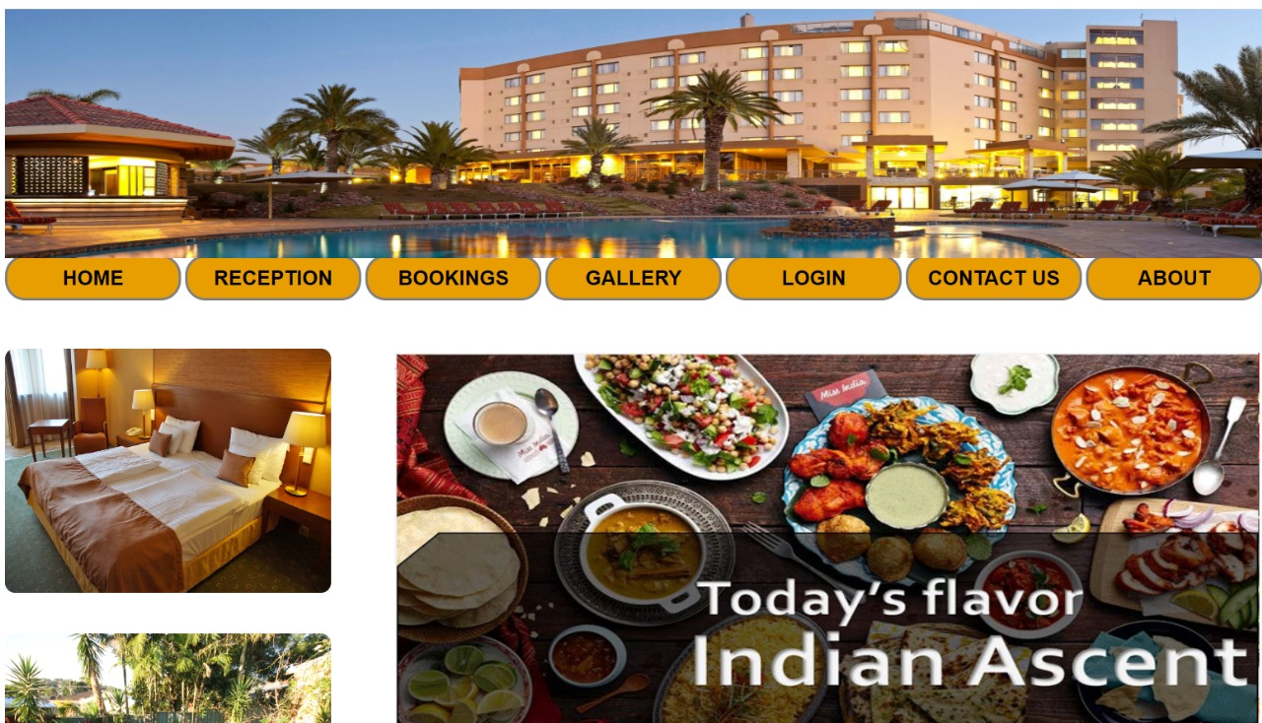

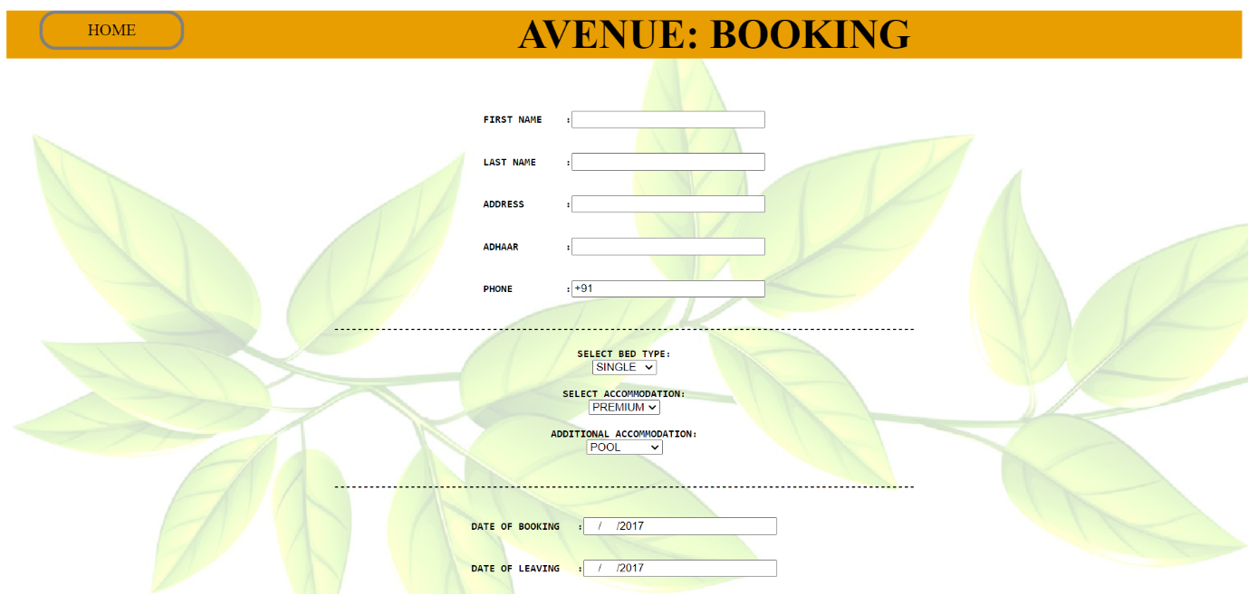

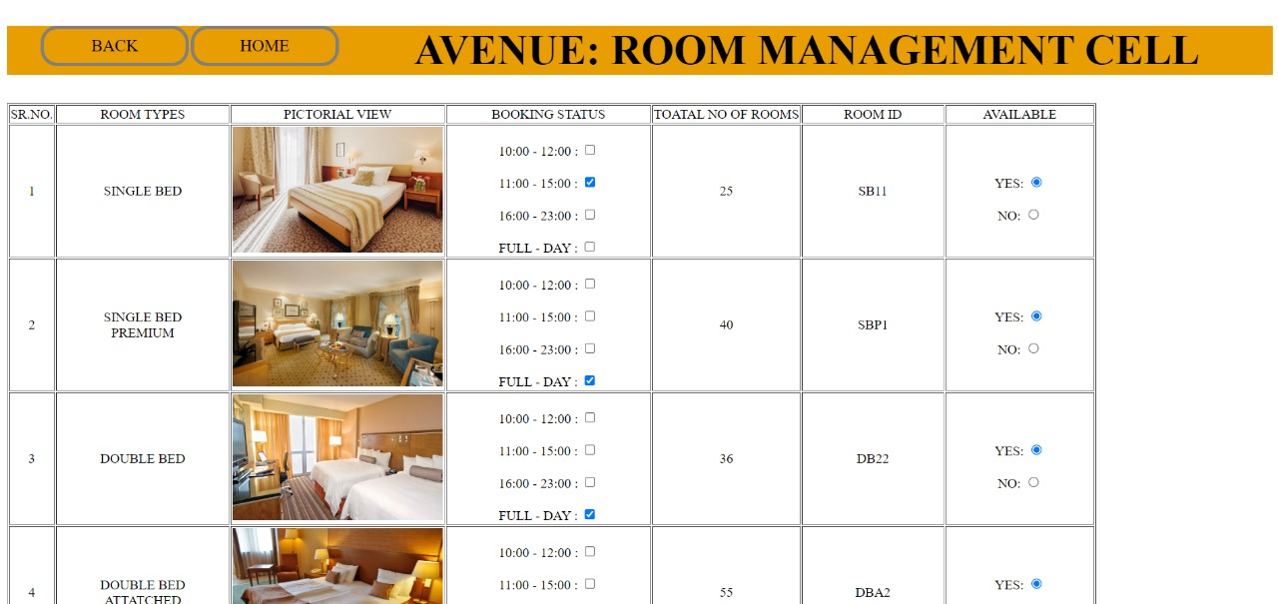

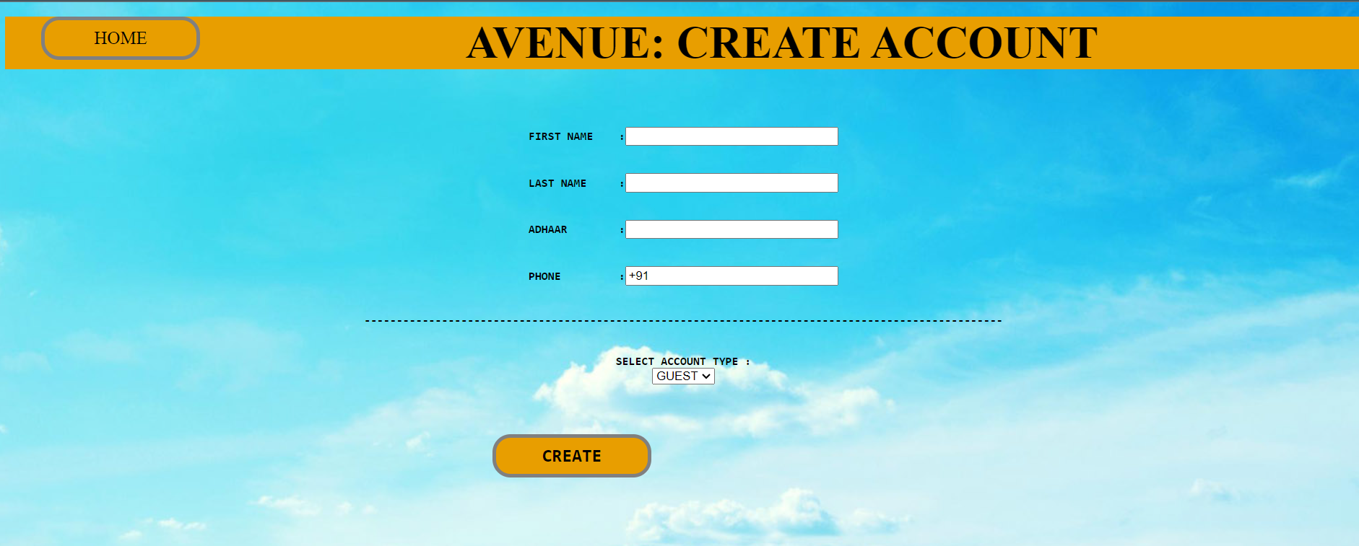

### 9. CONCLUSION

### The implementation of a “Hotel Management System (HMS)” signifies a major step forward in the hospitality industry, bringing numerous benefits that enhance operational efficiency, customer satisfaction, and overall management. By automating and integrating various hotel operations such as reservations, check-ins, check-outs, billing, housekeeping, and customer service, the system transforms the way hotels function, offering a more streamlined and effective approach to managing hotel activities.

### 9.1 Future Enhancements

Moreover, the future of the Hotel Management System (HMS) could see significant advancements in automation and robotic technology. For instance, automated concierge services and robotic room service delivery can enhance efficiency and provide unique guest experiences. Robots can handle repetitive tasks such as luggage transport and room deliveries, allowing staff to focus on more complex customer service interactions. This not only improves operational efficiency but also adds a novelty factor that can attract guests seeking innovative experiences.

Enhancing cybersecurity measures will be critical as hotels increasingly rely on digital systems. Implementing advanced encryption techniques, multi-factor authentication, and continuous security monitoring can safeguard sensitive guest data and protect against cyber threats. Ensuring robust data protection protocols will build guest trust and comply with stringent data privacy regulations.

The integration of virtual rety (VR) and augmented reality (AR) can also revolutionize the guest experience. VR can offer virtual tours of hotel facilities, enabling guests to explore rooms and amenities before booking. AR can enhance on-site experiences, providing interactive information about hotel features, local attractions, and personalized recommendations directly to guests' smartphones or AR glasses.

Finally, adopting sustainable and eco-friendly technologies will be crucial for the future of HMS. Implementing energy-efficient systems, smart lighting, water conservation technologies, and waste management solutions can help hotels reduce their environmental footprint. Sustainable practices not only appeal to environmentally conscious travelers but also contribute to long-term cost savings and compliance with environmental regulations.

In summary, the future enhancements of HMS involve leveraging advanced technologies such as AI, IoT, robotics, cybersecurity, blockchain, VR, AR, and sustainable practices to elevate operational efficiency, security, guest experience, and environmental sustainability. These innovations will ensure that hotels remain competitive and can meet the evolving expectations of modern travelers.

**REFERENCES**

1. Kot, S. (2014). "The role of information and communication technology in the hotel management system." International Journal of Business and Social Science, 5(7), 202-208.
2. Ivanov, S. (2019). "Robots, artificial intelligence, and service automation in hotels." International Journal of Contemporary Hospitality Management, 31(7), 2540-2563.
3. *Forbes*: "How AI And Machine Learning Are Transforming Travel." forbes.com
4. "Hotel 2025: Embracing Change in Hospitality" - A comprehensive report on future trends and technologies in the hospitality industry.
5. Xiang, Z., & Gretzel, U. (2010). "Role of social media in online travel information search." Tourism Management, 31(2), 179-188.
6. Stein, A., & Ramaseshan, B. (2019). "Customer experience management: An exploratory study of theme park visitors." Journal of Hospitality and Tourism Management, 38, 64-76.
7. Werthner, H., & Ricci, F. (2004). "E-commerce and tourism." Communications of the ACM, 47(12), 101-105.
8. Baloglu, S., & Pekcan, Y. A. (2006). "The website design and Internet site marketing practices of upscale and luxury hotels in Turkey." Tourism Management, 27(1), 171-176.
9. Buhalis, D., & Law, R. (2008). "Progress in information technology and tourism management: 20 years on and 10 years after the Internet—The state of eTourism research." Tourism Management, 29(4), 609-623.
10. Bowie, D., & Buttle, F. (2004). "Hospitality marketing: an introduction." Hospitality Management, 23(3), 315-328.